THE SHEPHERDS WALKING STICK

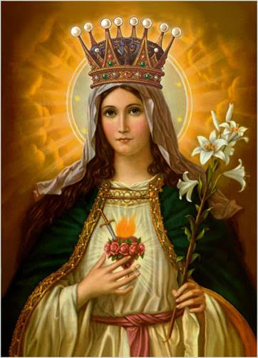
In October 1633, the villagers of Oberammergau in Bavaria, Germany vowed to God that if He will end the plague, they will perform a play depicting Jesus’ life and death every ten years. The plague ended, and the famous Oberammergau Passion Play was first performed the year after. During an epidemic plague in 1522, the people of Rome carried the crucifix of San Marcello around the city and the plague eventually died out. Personally, I don’t believe that in both historical cases, plagues suddenly ended. It sounds like the stuff of legends. What I believe is that following the devotional acts of the people, the plagues followed a curve until they ultimately ended. But, why am I telling you this? It is because I feel scared and almost desperate that covid-19 cases are spiking up especially here in Manitoba. As of writing, Friday, August 21, there are 34 new cases today; the day before there were 33 new cases bringing to a total of 265 active cases. Are people being careless? Maybe, but I do not want to be the judge of that. What about praying? Are we praying hard and enough? In this regard, I think there is more we can do. So, I am proposing that after the 5 PM Mass (Sunday Vigil) every Saturday, we will process the Blessed Sacrament outside of the church while praying the Holy Rosary. It may take a 30-minute delay of the dinner schedule, so what do you think about that?.......... August 22 is the feast of the Queenship of Mary. It is a relatively new feast in the church calendar. It was established by Pope Pius XII in 1954. However, the title of Mary as queen is solidly biblical. At the Annunciation, the angel said to Mary that God the Most High will give her Son the throne of David. We can say, therefore, that the queenship of Mary is by virtue of her oneness with Jesus who is King par excellence. We have to keep in mind that among the ancients, it is not the queen-wife of the king that has the greatest influence in the kingdom but the queen-mother. No wonder that as early as the 4th century, Christians especially St. Ephrem already referred to Mary as “Queen” or “Lady”. Church Fathers and Doctors of the Church continued to use the title, thus in the Middle Ages and until now, we have these known hymns and prayers such as the Hail, Holy Queen. When Pope Pius XII instituted the feast of the Queenship of Mary through the encyclical To The Queen of Heaven, he wrote that Mary deserved the title because of her perfect discipleship, her association in the redemptive work of Jesus, and because of the power of her intercession.

